|  |  |
| --- | --- |
| Ex No: 7 | **Implementation of Database as a Service using Firebase** |
| Date: 25-03-2022 |

**Aim:**

To create the project in Firebase (open source) and also create the database in the cluster and performing following operations:

1) Insert One Record

2) Insert Many Records

3) List all the Records

4) List the Particular Record

5) Update the Record

6) Delete the Record

**Procedure:**

**Create a Database in the Cloud With Firebase**

• Before you proceed, make sure you have the following installed and

configured on your computer:

• Python 3.4 or higher

• pip 18.0 or higher

1. Go to <https://console.firebase.google.com/>

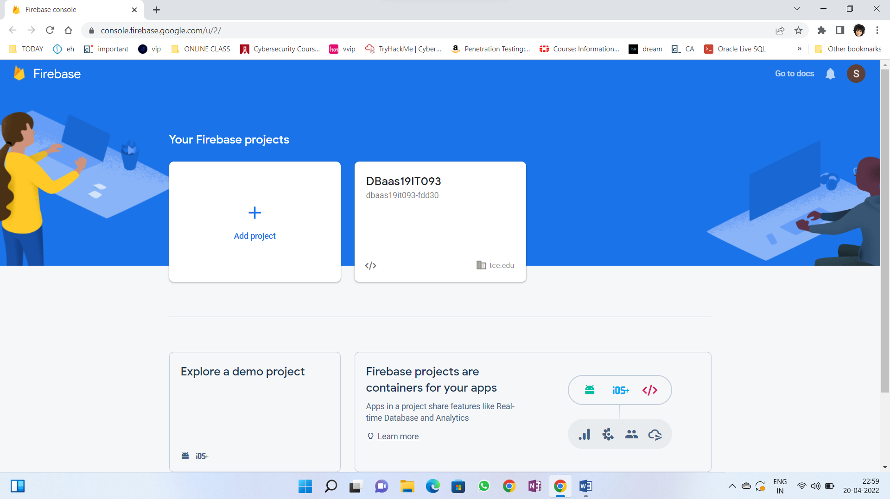

1. Add project

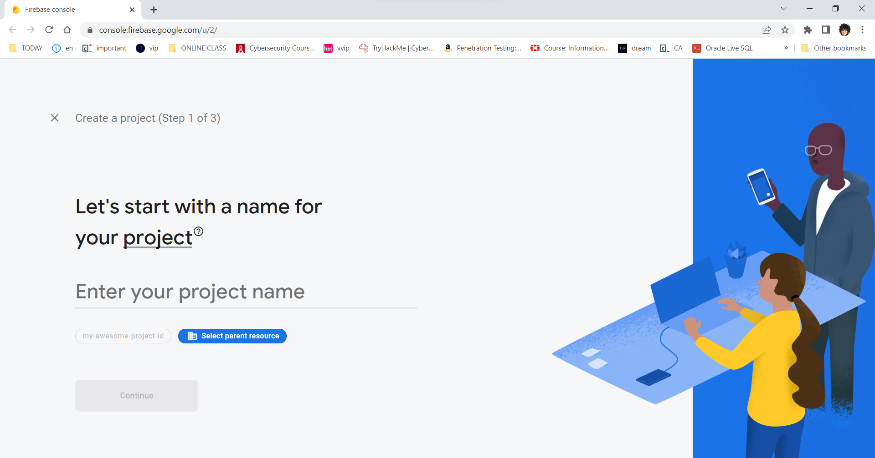

1. Create real time database

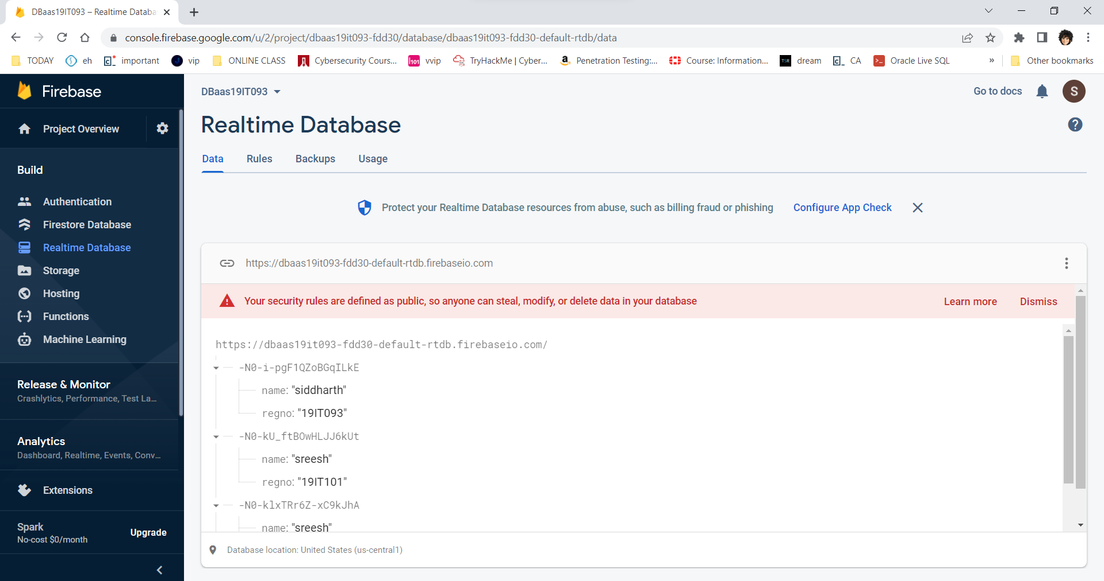

1. Set rules

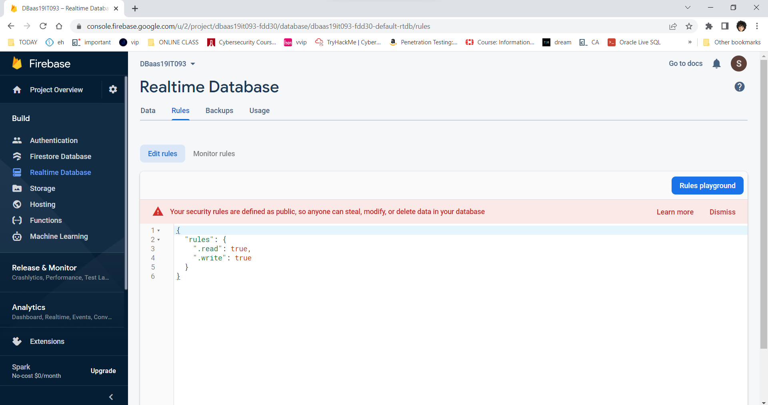

1. Go to project settings, copy firebaseConfig.

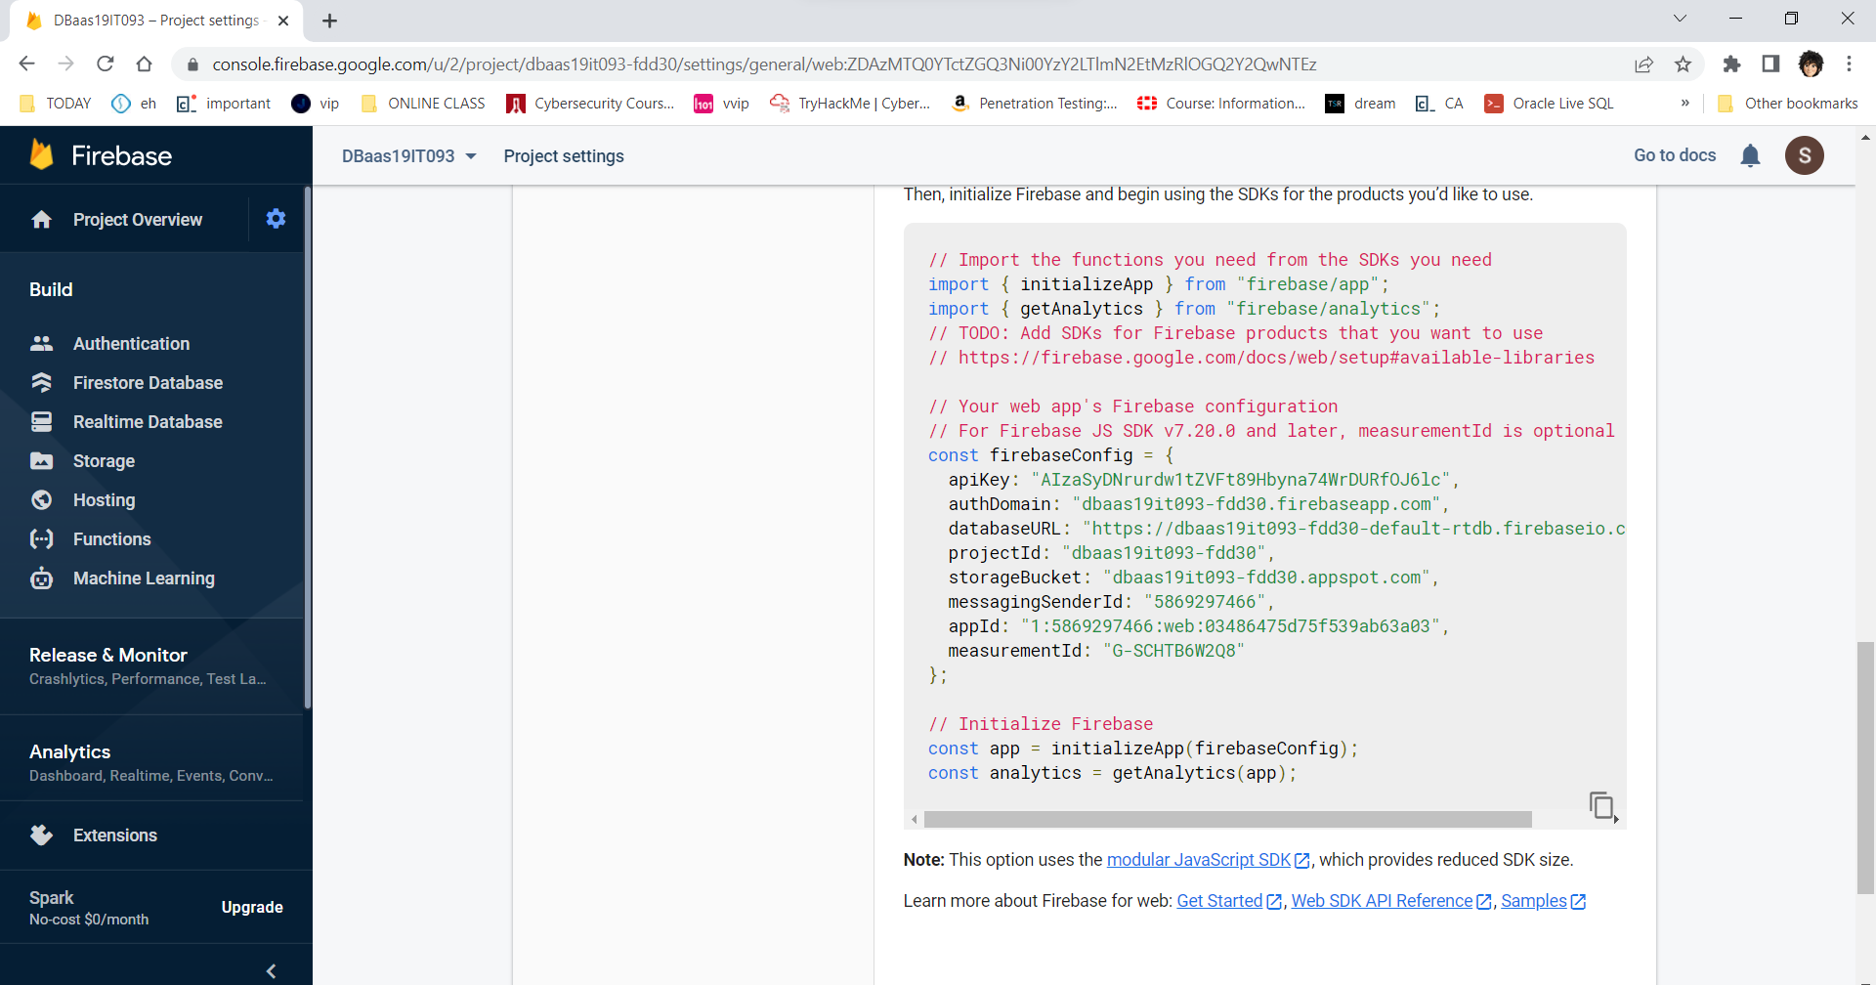

1. Open google colab, install pyrebase. Connect to the firebase database

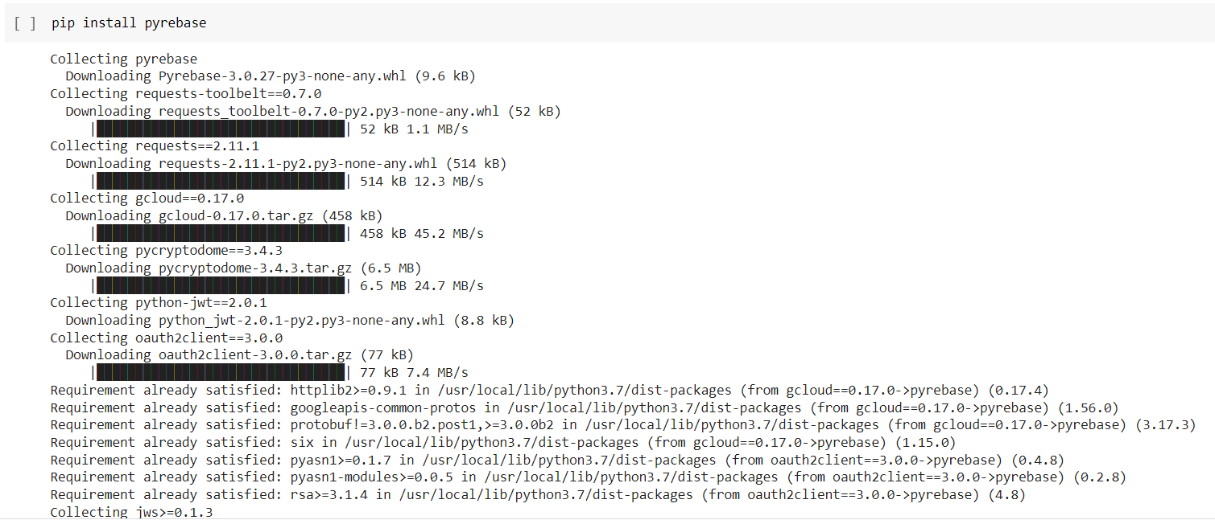

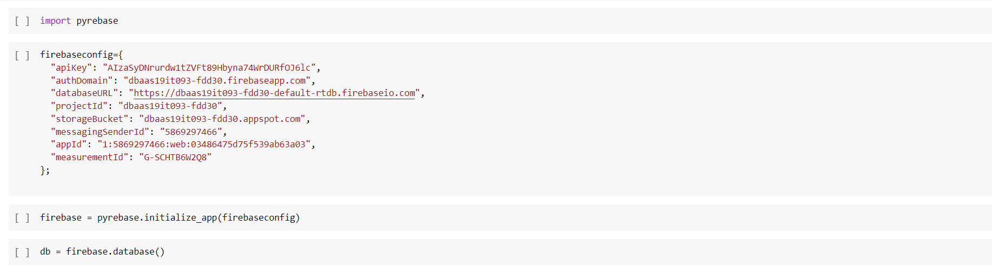

1. **Insert one record**

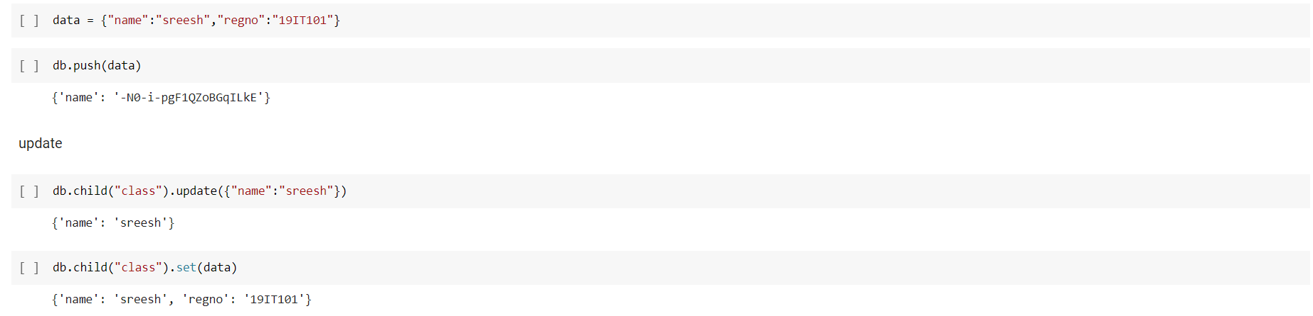

1. **Insert Many records**

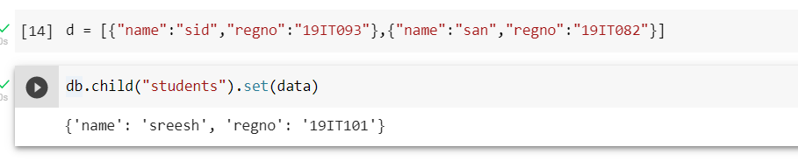

1. **List all records**

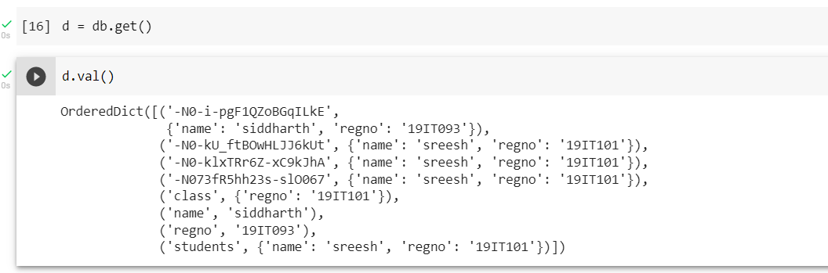

1. **List particular record**

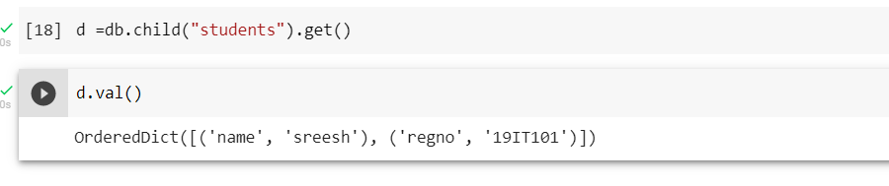

1. **Update record**

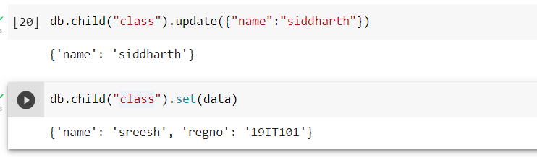

1. **Delete record**

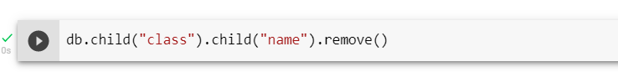

**Result:**

Thus, the operations like insert, update, delete, to find records in the Firebase using python programming.